# **Invert Binary Tree**

Given the root of a binary tree, invert the tree, and return *its root*.

**Example 1:**

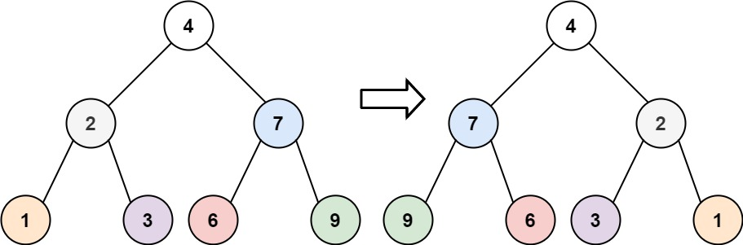

**Input:** root = [4,2,7,1,3,6,9]

**Output:** [4,7,2,9,6,3,1]

**Example 2:**

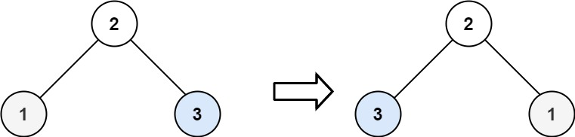

**Input:** root = [2,1,3]

**Output:** [2,3,1]

**Example 3:**

**Input:** root = []

**Output:** []

/**

* Definition for a binary tree node.

* public class TreeNode {

* public int val;

* public TreeNode left;

* public TreeNode right;

* public TreeNode(int val=0, TreeNode left=null, TreeNode right=null) {

* this.val = val;

* this.left = left;

* this.right = right;

* }

* }

*/

public class Solution {

public TreeNode InvertTree(TreeNode root) {

Swap(root);

return root;

}

void Swap(TreeNode root)

{

if(root == null)

{

return;

}

TreeNode t = root.left;

root.left = root.right;

root.right = t;

Swap(root.left);

Swap(root.right);

}

}